2019 Proposed Vermont Building Energy Standards
Training and Code Process Update

Training Update:

Tuesday, June 11, 2019
8:00am – 4:30pm
Burlington Electric Department Auditorium
585 Pine Street, Burlington, VT

The Vermont Department of Public Service, in partnership with Efficiency Vermont, is pleased to bring you a free training on the proposed 2019 Vermont Commercial and Residential Building Energy Standards (CBES and RBES).

Attendees will learn about a variety of topics and will also have opportunities to ask technical questions of the presenters.

This training is open to the public and is being offered as two sessions (RBES from 8:30 – 12 and CBES from 12:30 – 4:30). Attendees may choose to register for one or both sessions.

Each session is eligible for 3 AIA credits, .86 BPI credits, as well as three professional credit hours for Efficiency Excellence Network members.
Register Today
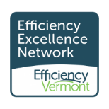
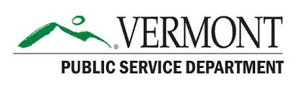

-------------------------------------------------------------------------------------------------------------
A Message from the PSD on the Code Update Process:
The 2019 Proposed Vermont Building Energy Standards information is now posted on-line at:
https://secure.vermont.gov/SOS/rules/index.php

A public hearing has been scheduled for June 21st, 2019 in Room 11 at the Vermont State House in Montpelier. The RBES hearing will be held in the morning and CBES held in the afternoon. More details will be posted at the Department of Public Service website in June:
https://publicservice.vermont.gov/content/building-energy-standards-update

While the public comment period is open through July 10, 2019, we strongly encourage you to submit your comments by June 18th, so that we may be able to address and discuss them in a more interactive manner (if possible) during the public hearing.
RBES comments may be sent to: PSD.CodeUpdateRes@vermont.gov
CBES comments may be sent to: PSD.CodeUpdateComm@vermont.gov

